**6、Graph Neural Networks with Generated Parameters for Relation Extraction（用于关系抽取的具有生成参数的图神经网络）**

**ACL ’19**

**作者**：Hao Zhu, Yankai Lin, Zhiyuan Liu, Jie Fu, Tat-seng Chua, Maosong Sun

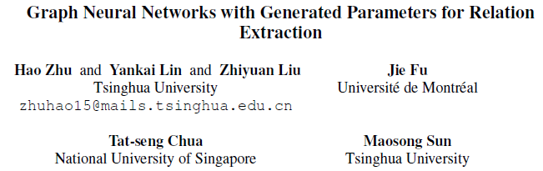

**摘要**：近年来，在改进机器学习领域的关系推理方面取得了一些进展。

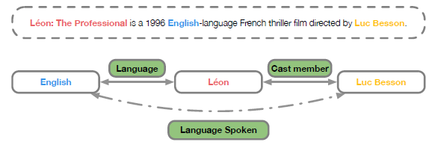

【问题描述】Figure 1: An example of relation extraction from plain text. Given a sentence with several entities marked, we model the interaction between these entities by generating the weights of graph neural networks. Modeling the relationship between “L´eon” and “English” as well as “Luc Besson” helps discover the relationship between “Luc Besson” and “English”.

在现有的模型中，**图神经网络(GNNs)是最有效的multi-hop关系推理方法之一**。事实上，在关系抽取等自然语言处理任务中，multi-hop关系推理是必不可少的。**本文提出了一种**

**基于自然语言语句生成图神经网络(GP-GNNs，**generated parameters**)参数的方法，**

**使神经网络能够对非结构化文本输入进行关系推理。**

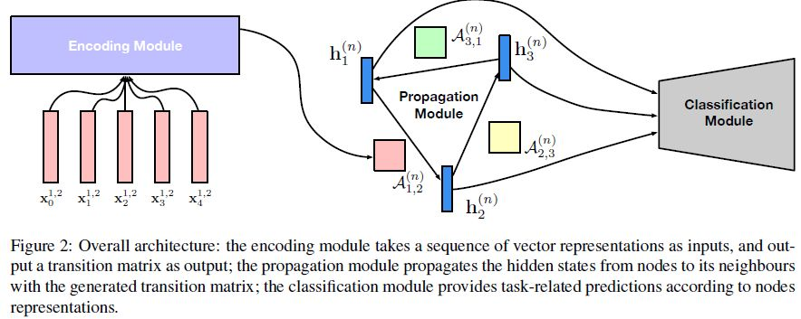

three modules to process relational reasoning:

1) an encoding module which enables edges to encode rich information from natural languages

2) a propagation module which propagates relational information among various nodes, and (

多层，n 表示

3) a classification module which makes predictions with node representations.

所谓分类=预测边（节点对）的类型

我们验证了从文本中提取关系的GPGNN。 实验结果表明，与baseline相比，我们的模型取得了显著的改进。我们还进行了定性分析，证明我们的模型可以通过multi-hop关系推理发现更精确的关系。

**网址**：

https://arxiv.org/abs/1902.00756